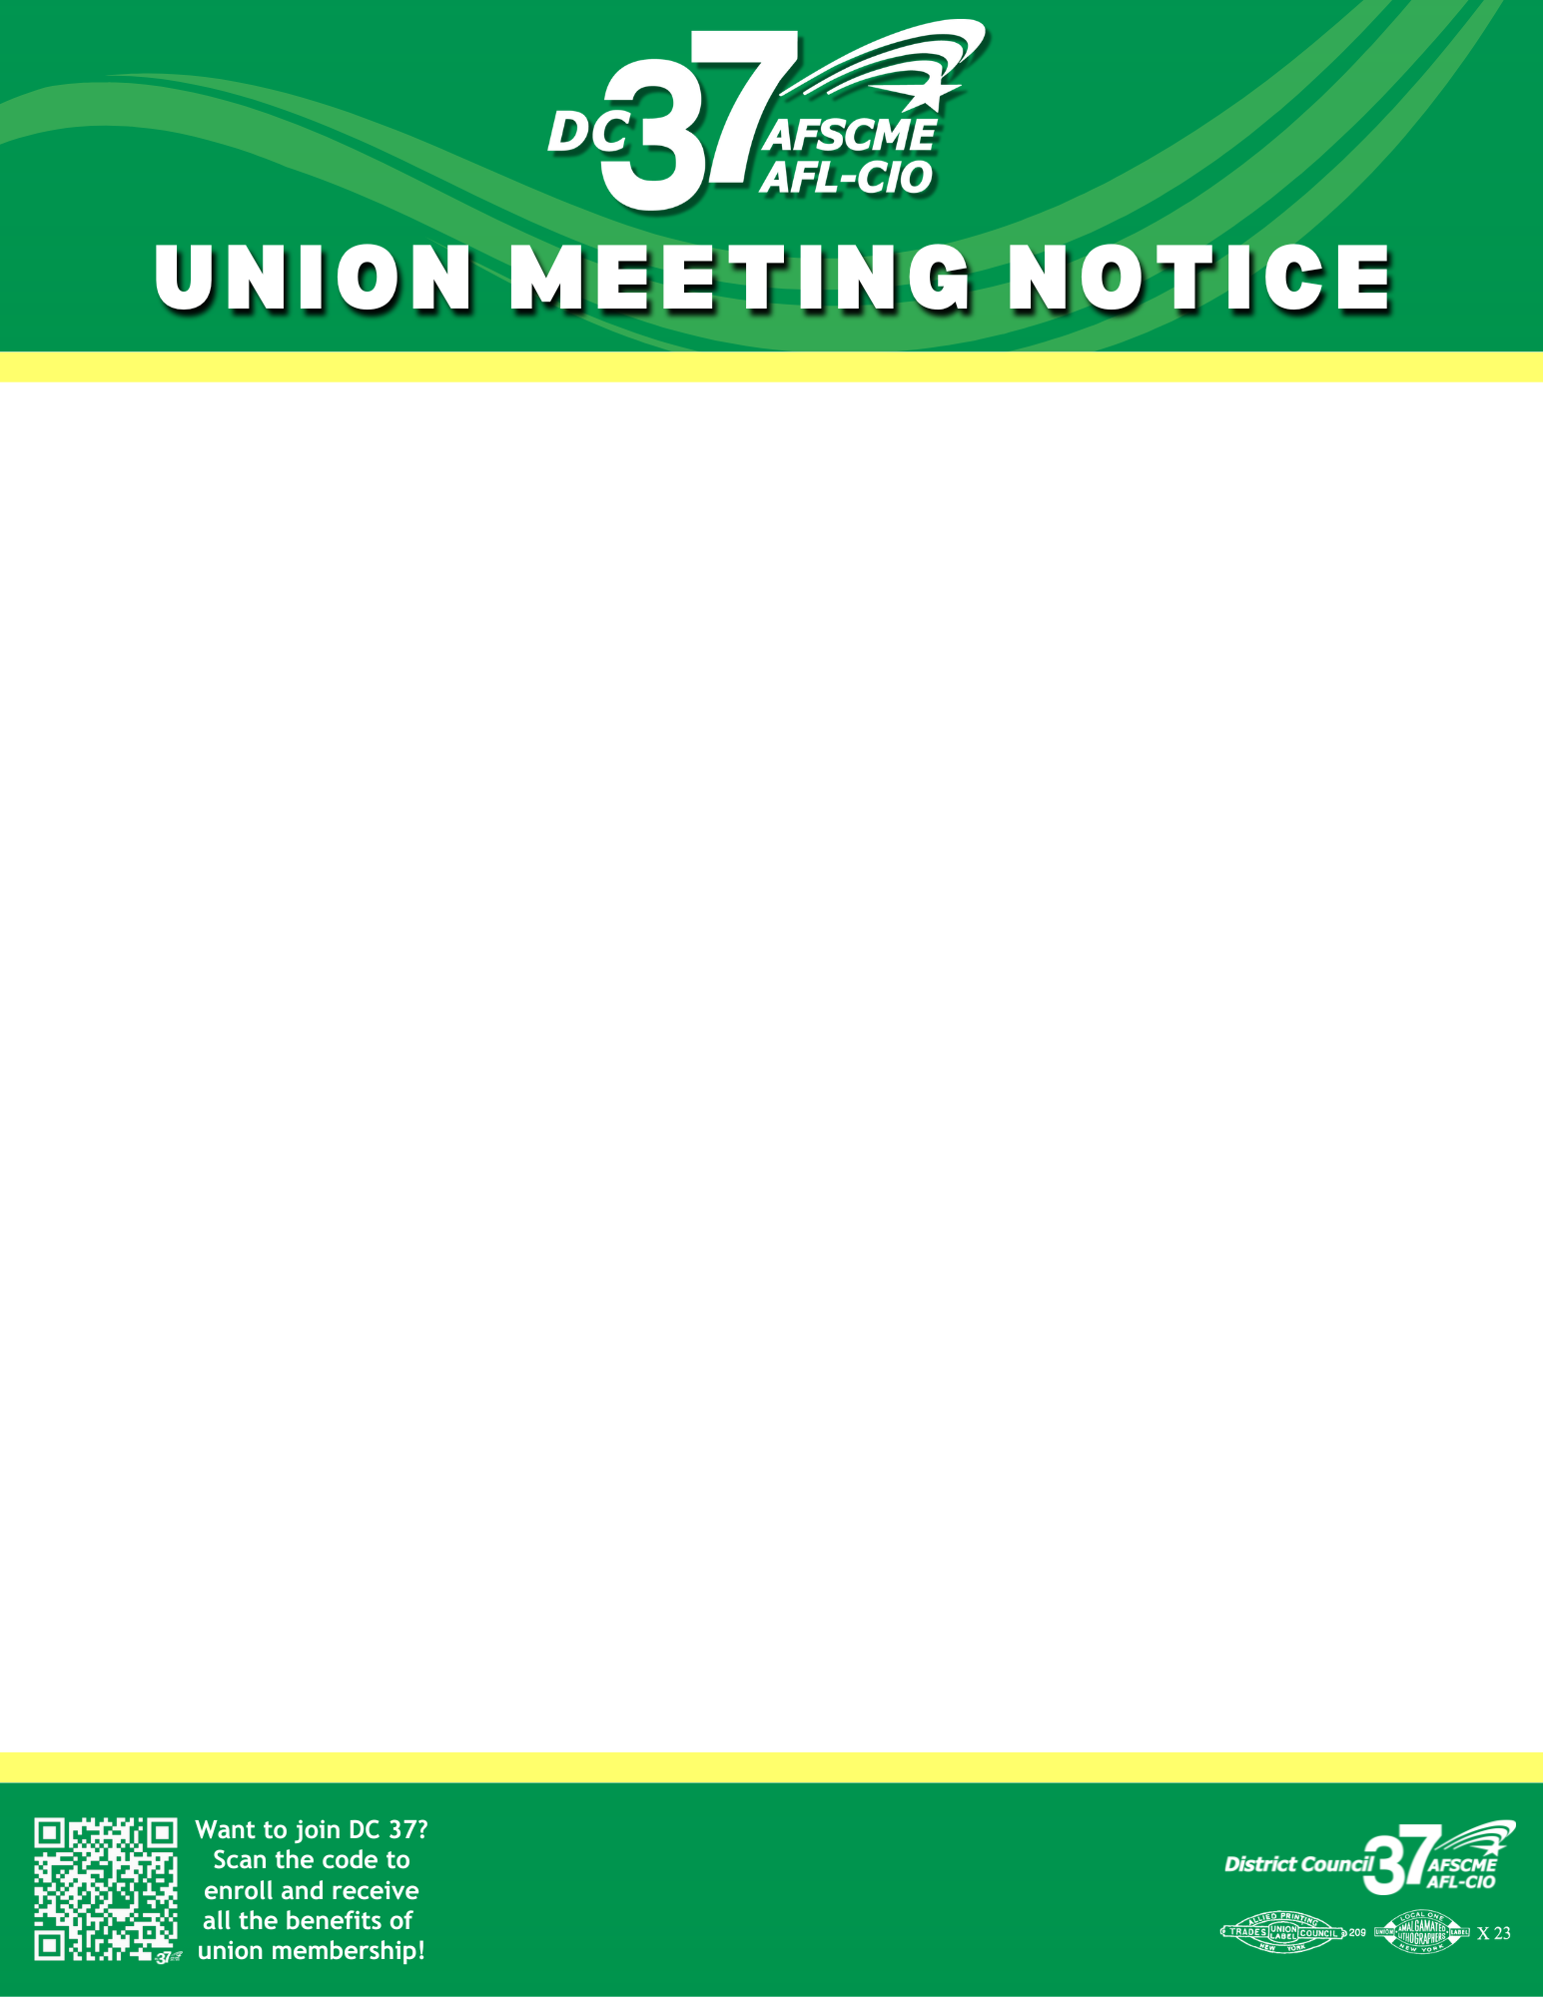

OPEN TO ALL LOCAL 3652 MEMBERS
NYC MTA

Join us for a Lunchtime meeting

Date: Tuesday September 22, 2026
Time: 12 – 1 pm
1 – 2 pm

Location: 2556 Mcdonald Ave, Brooklyn, N.Y 11223
Building- Coney Island Overhaul Complex
Conference Room# 217 B
AGENDA
- DC 37/Local Updates
- PAC/P.E.O.P.L.E.
- Work Concerns
- Questions & Answers

Questions: Contact DC 37 Grievance Representative Melissa M. Tirado (212)815-1044, (646)939-2203, Email: Mtirado@dc37.net

